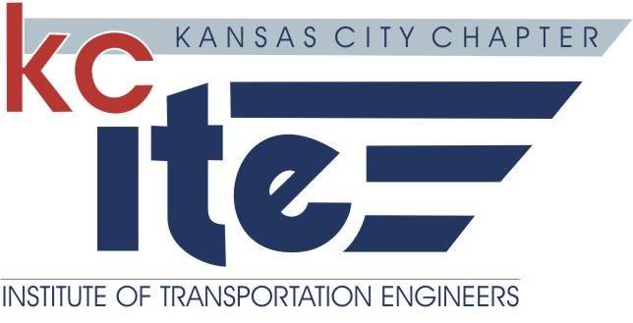
Professional Development Certificate of Attendance
KCITE Event:  KCITE Chapter Training | Title of Program:  “Emergency Operations Center Tour”
Date of Program:  April 21, 2016 | Presenter, Instructor or Speaker:  Jennifer Fales, Emergency Management Coordinator, Kansas City, MO
Location of Event:

Kansas City
Emergency Operations Center
635 Woodland, Suite 2107
Kansas City, MO 64106

Length of Program (Speaker Presentation Only):  1.5 Hours | Professional Development Hours (PDH):  1.5
The Kansas City Chapter of the Institute of Transportation Engineers certifies that the sponsored program was presented as indicated above. Only individuals attending this program have been issued a certificate.
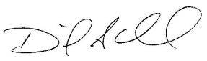

Signed:___________________________________ KCITE Vice President

