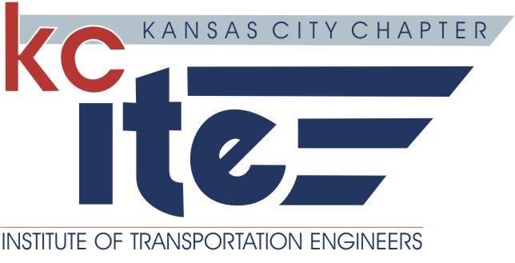
Professional Development Certificate of Attendance
KCITE: Event:  KCITE: July Chapter Meeting and Harvesters Food Drive | Title of Program:  Kansas City International Airport
Date of Program:  07/12/18 | Presenter, Instructors or Speakers:  Patrick Klein: Director of Aviation, Kansas City Aviation Dept.
Location of Event:

Black on Burlington
1327 Burlington Street
North Kansas City

Length of Program (Speaker Presentation Only):  One/Half Hour (.5 hour). | Professional Development Hours for Speaker (PDH):  Patrick Klein: (1 PDH)  Two Hour (2 PDH) per speaker.
The Kansas City Chapter of the Institute of Transportation Engineers certifies that the sponsored program was presented as indicated above. Only individuals attending this program have been issued a certificate.


Signed: KCITE Vice President

